**School Management System**

**Database Design Document**

Database Management System Project



**Group Id:** DB31

**Group Members:** 2016-CS-251

2016-CS-264

**Supervisor Name:** Ma’am Sehar

**Introduction:**

School Management System involves the complete management of not only the students and teachers but it also involves the management of their attendance, fees, pays and also handles any queries and requests.

All the important and basic management tasks are done by the admin. All the management of classes and sections is under the control of admin. Moreover they can also manage student and teacher accounts by viewing their details and reviewing their attendance. They will also manage the time table and payroll of teachers. Fee challans will also be issued by the admin. The date sheet viewed by the teacher and the student is also created by the admin!

Teacher is responsible for uploading and managing the assignments as well as marking the student attendance. Being a teacher he/she is able to grade the assignments and prepare the student result. Payroll and personal information can also be viewed by him/her

Whereas the student not only manages his/her account but can view fee information, time table, date sheet and many more.

Both the teacher and the student will be able to submit a request regarding any type of query they have!

This system will revolutionize the school system making the management of such organizations easy.

**Business Rules/Constraints:**

Assumed business rules are as follows:

* Admin can login to his/her account only if the password matches with the password stored in the database
* Admin can review the attendance of only those students that are already marked by the teacher
* Admin has to first add the teachers in order to mark their attendance and also specify their payroll
* Admin also has to add the students before generating their fee challan
* Teacher cannot login until and unless they are already added by the admin
* Teachers can only view the time table and date sheet they cannot edit them
* Teacher can only view personal information
* Teacher can mark attendance of only those students that are already added by the admin
* Teacher can generate results of only those students that are already added by admin
* Student cannot login before being added by the admin
* Students can only view personal information
* Students can submit the homework only after the teacher has uploaded it
* Students can view their academic result only after the teacher has generated it

**Logical Database design:**

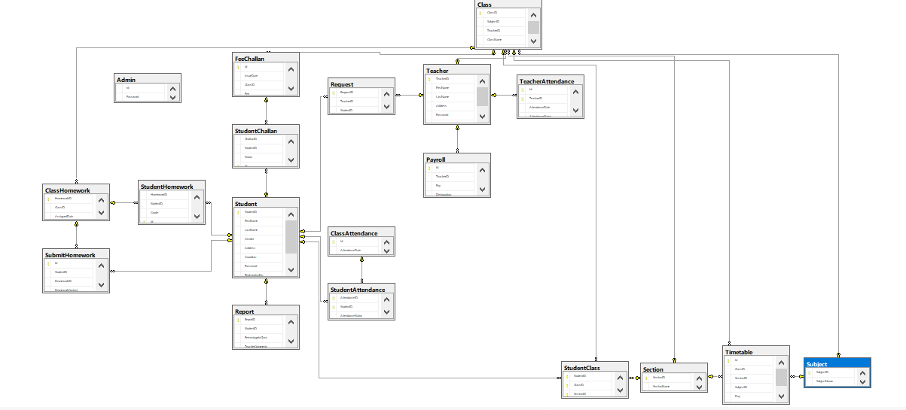

**Conceptual Design(ER Diagram):**

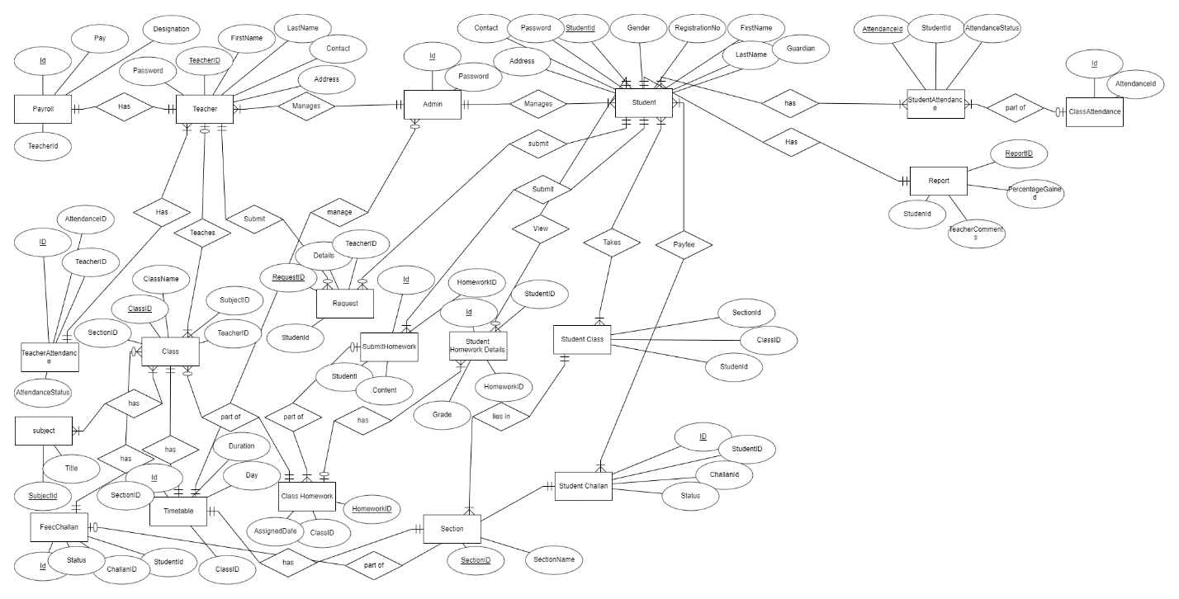

**List of reports:**

The reports that we want to generated in our project is as follows:

1. Teacher and Admin can generate class attendance report
2. Admin can generate Teacher Attendance Report
3. Student, Admin and Teacher can generate Student Result Report
4. Fee Challan of students
5. Date Sheets of classes
6. Time Table of different classes
7. Class wise result generated
8. Teacher can generate home reports of each class
9. Teacher and student can generate homework report of students
10. Admin can generate List of students in each class
11. Admin can generate List of students in school
12. Admin can generate list of teachers in school

**Technology to be used:**

Asp.net web application will be used